[TDDD37] Project

## Normalization discussion

### 1NF

Since no entity contains multiple attributes of the same kind, no arrays or serializations of some kind are kept in a single table in the database.

### 2NF

Since no more than one single key is a candidate key (exept for the all columns as a key), then no nonprime attribute can be dependent on a part of a candidate key. Thus, the database is in 2NF.

### 3NF

No nonprime attribute is dependent on non-key, thus the database is in 3NF.

### BCNF

Nothing is determined by a nonprime attribute in the database, so it must be in BCNF as well.

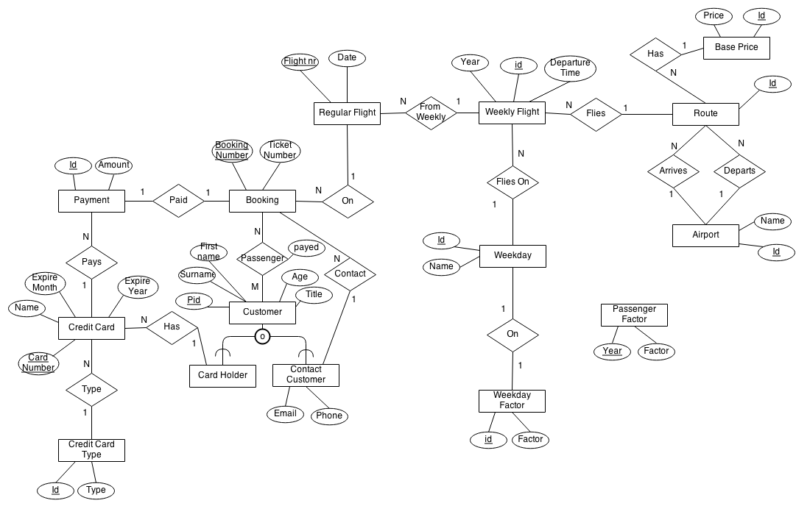

## Description and brief overview

**create_flights (IN start, IN days)**

Creates flights from a start date for a given amount of dates, based on the schedule made by the weekly_flights. These are to be considered abstract flights in a schedule, while the flights generated into regular_flights are considered concrete, actual flights. These are the ones where customers actually can reserve seats and make a booking for, while

**create_single_flight (IN cur_date)**

Creates a single set of flights for a given date. These flights are created from the weekly_schedule for the weekly_flights.

Creating flights for a day is only allowed once, any changes in the schedule will have to make you either remove the entries for the day you want to reschedule the booking for, or adding these manually by insert statements. This is because the create_single_flight is only guaranteed to generate unique ID:s once.

**reserve_seats(IN seats, IN flight_number)**

Reserves the given number of seats on the given flight, if there is room on the flight. By this, the number of paid bookings are only considered since a person is not guaranteed a seat until the flight has been paid. Until the booking is paid, seats are only reserved, and this does not guarantee a seat on the plain.   
This is done by creating the number of reservations as rows in the passenger_on table, where the customer field is left NULL and the payed field is left FALSE.

**add_passenger(IN booking_number, IN pid, IN title, IN first_name, IN last_name, IN age)**

Adds a passenger to a booking, given a booking number and the passengers credentials. This is a convenience method for not first inserting the customer into the customer table and then call add_existing_passenger().

**add_existing_passenger(IN booking_number, IN pid)**

Given the personal number for a person registered in the database, this procedure adds that person to a booking. This can be done at any time, just as long as the booking has been made (at this point called a reservation); it could either be done before or after the payment has gone through, but the person is only guaranteed a place if the booking is payed for.

If the booking does not have a contact customer,

**add_creditcard (IN card_number, IN type, IN expires_month, IN expires_year, IN customer)**

Adds a credit card to a customer, given the credentials of the credit card and the customer. Checks are performed whether the customer defined by the personal id passed to the procedure is actually in the Brian Air database. Further on, if the customer not already is in the database as a creditcard_customer, he/she will be inserted there. The name on the credit card is assumed to be the same as the person signing up with that card.

**pay_booking(IN booking_number, IN creditcard_number)**

Pays the given booking with the given creditcard. The price is calculated as defined in the assignment. A check is made if the reserved seats still are available. If that is not the case, the booking is cancelled and removed, as well as all the passenger from the passenger_on relation.

**get_flight_price(IN flight_num, OUT price)**

Calculates the current price for a flight.

**get_seats_taken(IN flight, OUT payed_seats)**

Returns how many seats that are reserved, booked and payed for on a given flight.

**flights_to(IN dest, IN date)**

Retrieves all flights to a given destination on a given date. The results are presented with current pricing for each flight, as well as the number of seats currently available. Creates a temporary table for presentation and viewing purposes, which is dropped after being displayed.

## Written answer for 1.d

**basepriceto:** The base price is determined by the route for a specific year.   
**weekdayfactorday:** Each weekday has a specific factor for a specific year.  
**passengerfactor**: The passengerfactor increases the price if many people are booked on it.

Upon payment of a booking the price is determined by   
basepriceto, from · weekdayfactorday · max(1, pass#flight) · passengerfactor /60

So, from the time of reservation the price may change until the booking is actually changed. The price can be later on be backtracked to the amount of the transaction that paid for the booking. For now, one can only pay the booking as a whole at once, part-payments are not allowed.

## Written answer for 1.e

At the time of adding a passenger to a booking, the age is checked. If the customer does not fulfill the demand that he/she must be of age 18, he/she cannot be added to the booking.

## Written answer for 1.f

We do not generate flights for more than one year in advance, so these are not bookable. An alternative to this would have been to implement a check for this condition, that the date of a regular flight is cannot be more then CURRENT_DATE+365 (days). This could either be done in the pay_booking() procedure if one wishes to let customers to be able to *reserve* but not *pay* for the booking earlier than one year ahead. Otherwise, if no reservations can be made either, this should be placed in the reserve_seats() procedure.

## Written answer for 3.g

A possible protection for this would have been to insert the credit card information with a given salt and a hash, or some similar encryption. This would make the credit card credentials harder to get over.

## Assignment 5

|  |  |
| --- | --- |
| **SESSION A** | **SESSION B** |
| **mysql> SET autocommit=0;**  **Query OK, 0 rows affected (0.00 sec)**  **mysql> SELECT * FROM booking;**  **+----------------+-------------------+-------------+-----------+**  **| booking_number | ticket_number | contact | flight |**  **+----------------+-------------------+-------------+-----------+**  **| 1 | 6ce8966c2268a6309 | 600510-6493 | BA1411250 |**  **+----------------+-------------------+-------------+-----------+**  **1 row in set (0.00 sec)** |  |
|  | **mysql> SET autocommit=0;**  **Query OK, 0 rows affected (0.00 sec)**  **mysql> SELECT * FROM booking;**  **+----------------+-------------------+-------------+-----------+**  **| booking_number | ticket_number | contact | flight |**  **+----------------+-------------------+-------------+-----------+**  **| 1 | 6ce8966c2268a6309 | 600510-6493 | BA1411250 |**  **+----------------+-------------------+-------------+-----------+**  **1 row in set (0.00 sec)** |
| **mysql> CALL reserve_seats(6, 'BA1411250');**  **Query OK, 1 row affected (0.01 sec)**  **mysql> SELECT * FROM booking;**  **+----------------+-------------------+-------------+-----------+**  **| booking_number | ticket_number | contact | flight |**  **+----------------+-------------------+-------------+-----------+**  **| 1 | 6ce8966c2268a63a6 | 600510-6493 | BA1411250 |**  **| 2 | NULL | NULL | BA1411250 |**  **+----------------+-------------------+-------------+-----------+**  **2 rows in set (0.00 sec)** |  |
|  | **mysql> SELECT * FROM booking;**  **+----------------+-------------------+-------------+-----------+**  **| booking_number | ticket_number | contact | flight |**  **+----------------+-------------------+-------------+-----------+**  **| 1 | 6ce8966c2268a6309 | 600510-6493 | BA1411250 |**  **+----------------+-------------------+-------------+-----------+**   1. **row in set (0.00 sec)** |

1. No, the booking is not visible in session B. This is because of the issued command
2. **SET autocommit=0**which, according to the MySQL reference manual *“changes to transaction-safe tables (such as those for InnoDB, […]) are not made permanent immediately. You must use COMMIT to store your changes to disk…”*. So, changes are only stored locally until they are commited, and since no commit has been made, session B cannot see the changes in the database.

|  |  |
| --- | --- |
| **SESSION A** | **SESSION B** |
| **mysql> SELECT * FROM booking;**  **+----------------+-------------------+-------------+-----------+**  **| booking_number | ticket_number | contact | flight |**  **+----------------+-------------------+-------------+-----------+**  **| 1 | 6ce8966c2268a63a6 | 600510-6493 | BA1411250 |**  **| 2 | NULL | NULL | BA1411250 |**  **+----------------+-------------------+-------------+-----------+**  **2 rows in set (0.00 sec)**  **mysql> CALL add_existing_passenger(2, '810217-8485');**  **Query OK, 1 row affected (0.01 sec)** |  |
|  | **mysql> CALL add_existing_passenger(2, '400316-1354');**  **ERROR 1205 (HY000): Lock wait timeout exceeded; try restarting transaction** |

1. A deadlock occours when session B tries to write to the table. After some 60 seconds of trying to write to the table, the timeout is exceeded.